**AERO 430 – Exam 2**



Antonio Diaz ‘22

UIN 327003625

**Due 04/14/2020**

**1)** **Analytical Solution to 2D Heat Equation for infinitely long plate.**

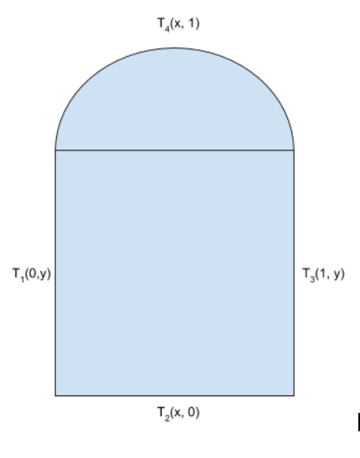

Case 1 Boundary conditions:

Case 2 Boundary conditions:

, where K is a conductivity constant.

Constants are defined as follows:

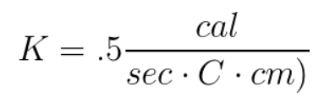

Length = 1 cm

Radius = .1 cm

The governing equation describing heat flow across any surface is .

Following the conservation of heat flow, Q is defined as:

This can be reduced by simplifying the K constants,

**Separation of variables to solve Dirichlet** **2nd order homogenous differential equation:**

The heat function can be separated into . Plugging back into PDE:

or

Boundary Conditions for Case 1:

Boundary Conditions for Case 2:

General solution to :

from boundary conditions

gives us A = 0

gives us , n is any integer

This gives us

General solution to :

from boundary conditions

= 0

This system of equations combined with boundary conditions reduces to:

Final General Solution to Heat Equation:

This heat temperature function is graphed below:

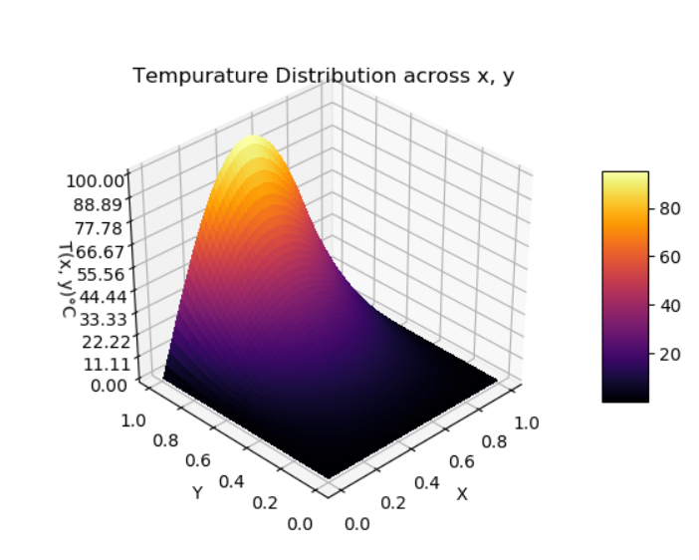 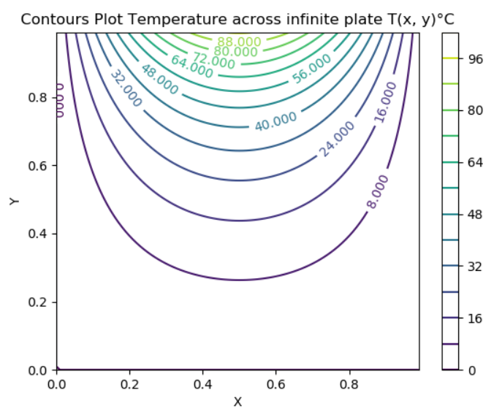

**2) FDM for point :**

Ordinary Taylor Series Expansion:

+ Error

+ Error

Taylor series expansion for point:

+

Subtracting Taylor series to find the second order approximation of U’:

=

Dividing both sides by gives us

Similarly, for

Adding Taylor series to find the second order approximation of U’’:

This is then reduced after removing truncation error, becomes:

Using the Taylor series similar for the fourth order approximation of U’’:

Simplifying these expressions using the

**3) Element equations using weak formulation with hierarchical basis function:**

Replacing the previously derived g(x) function with psi functions from the hierarchical basis function leads to:



Applying to a discretized T:

,

where

Plugging in discretized T:







Expansion to the alpha term can be simplified by factoring out the psi terms:



A system of equations can now be setup for the first element by setting

dx:

For p = 2, the following system of equations is formed:

m = 1:



m = 2:



m = 3:



This can be reorganized into matrix form for the element (“local stiffness”) matrix:

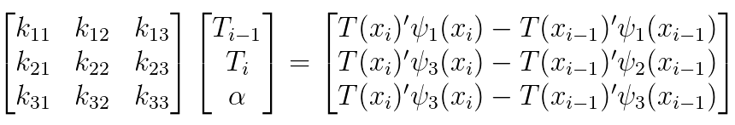

Which can be further simplified using our basis function:

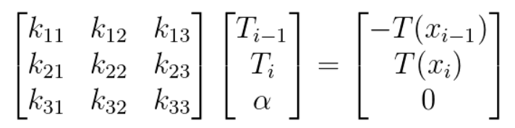

**4. Assembly and condensation of element matrix into the global stiffness matrix:**

Two consecutive element matrices result in the following:

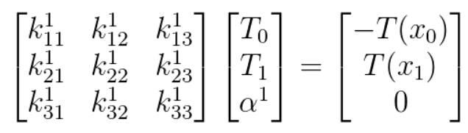

:

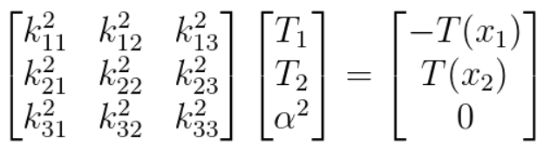

To make use of the element matrices, the elements are combined in a global matrix dependent on the number of nodes that are formed from 2x2 matrices that are formed with condensation.

p = 1, 4 elements:

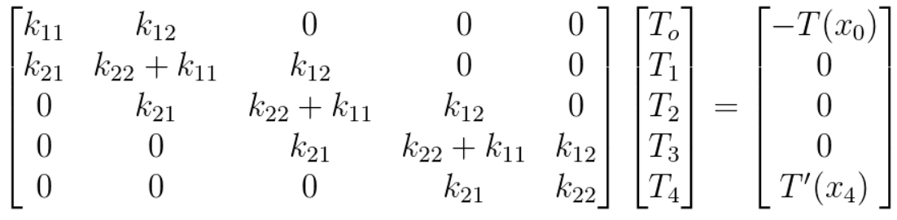

p = 2, 4 elements:

Condensed matrix: Using coefficients for each inner node, each 3x3 matrix can be condensed into a 2x2 matrix, then assembled in a similar way to p = 1, 4 elements:

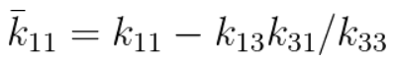

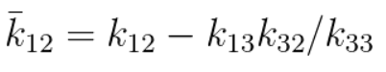

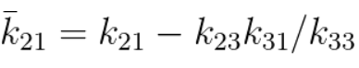

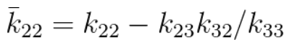

*these values are found with Kramer’s rule and can be replicated using Schur’s complement derived for p = 5

These values are used to reduce each node 3x3 matrix to 2x2 matrices, and assembled into the following:

for p =2, 4 elements

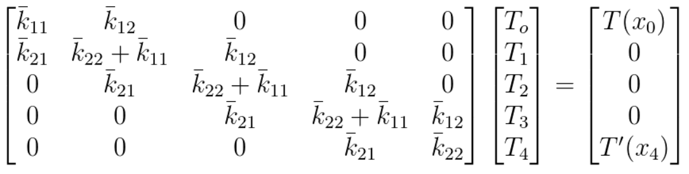

p = 3 condensation. Out of convenience, the next coefficients will be shown as variables in Python. The method of condensation for each new coefficient starts to become complex very fast:

k_11_bar = k_11 + k_13*(-k_31*k_44 + k_41*k_34)/(k_33*k_44 - k_34*k_43) +

k_14*(-k_41*k_33+k_31*k_43)/(k_33*k_44-k_34*k_43)

k_12_bar = k_12 + k_13*(-k_32*k_44 + k_42*k_34)/(k_33*k_44 - k_34*k_43) +

k_14*(-k_42*k_33+k_32*k_43)/(k_33*k_44-k_34*k_43)

k_21_bar = k_21 + k_23*(-k_31*k_44 + k_41*k_34)/(k_33*k_44 - k_34*k_43)+

k_24*(-k_41*k_33+k_31*k_43)/(k_33*k_44-k_34*k_43)

k_22_bar = k_22 + k_23*(-k_32*k_44 + k_42*k_34)/(k_33*k_44 - k_34*k_43) +

 k_24*(-k_42*k_33+k_32*k_43)/(k_33*k_44-k_34*k_43)

p = 4 condensation coefficients

k_11_bar = k_11 + k_13 * (-k_31*k_44*k_55 - k_51*k_34*k_45 - k_41*k_35*k_54 + k_51*k_44*k_35 + k_31*k_54*k_45 + k_41*k_34*k_55)/(k_33*k_44*k_55 + k_34*k_45*k_53 + k_35*k_43*k_54 - k_53*k_44*k_35 - k_54*k_45*k_33 - k_55*k_43*k_34) + k_14*(-k_41*k_33*k_55 - k_31*k_53*k_45 - k_51*k_35*k_43 + k_41*k_53*k_35 + k_51*k_45*k_33 + k_31*k_43*k_55)/(k_33*k_44*k_55 + k_34*k_45*k_53 + k_35*k_43*k_54 - k_53*k_44*k_35 - k_54*k_45*k_33 - k_55*k_43*k_34) + k_15*(-k_51*k_33*k_44 - k_41*k_53*k_34 - k_31*k_43*k_54 + k_31*k_53*k_44 + k_41*k_54*k_33 + k_51*k_43*k_34)/(k_33*k_44*k_55 + k_34*k_45*k_53 + k_35*k_43*k_54 - k_53*k_44*k_35 - k_54*k_45*k_33 - k_55*k_43*k_34)

k_12_bar = k_12 + k_13 * (-k_32*k_44*k_55 - k_52*k_34*k_45 - k_42*k_35*k_54 + k_52*k_44*k_35 + k_32*k_54*k_45 + k_42*k_34*k_55)/(k_33*k_44*k_55 + k_34*k_45*k_53 + k_35*k_43*k_54 - k_53*k_44*k_35 - k_54*k_45*k_33 - k_55*k_43*k_34) + k_14*(-k_42*k_33*k_55 - k_32*k_53*k_45 - k_52*k_35*k_43 + k_42*k_53*k_35 + k_52*k_45*k_33 + k_32*k_43*k_55)/(k_33*k_44*k_55 + k_34*k_45*k_53 + k_35*k_43*k_54 - k_53*k_44*k_35 - k_54*k_45*k_33 - k_55*k_43*k_34) + k_15*(-k_52*k_33*k_44 - k_42*k_53*k_34 - k_32*k_43*k_54 + k_32*k_53*k_44 + k_42*k_54*k_33 + k_52*k_43*k_34)/(k_33*k_44*k_55 + k_34*k_45*k_53 + k_35*k_43*k_54 - k_53*k_44*k_35 - k_54*k_45*k_33 - k_55*k_43*k_34)

k_21_bar = k_21 + k_23 * (-k_31*k_44*k_55 - k_51*k_34*k_45 - k_41*k_35*k_54 + k_51*k_44*k_35 + k_31*k_54*k_45 + k_41*k_34*k_55)/(k_33*k_44*k_55 + k_34*k_45*k_53 + k_35*k_43*k_54 - k_53*k_44*k_35 - k_54*k_45*k_33 - k_55*k_43*k_34) + k_24*(-k_41*k_33*k_55 - k_31*k_53*k_45 - k_51*k_35*k_43 + k_41*k_53*k_35 + k_51*k_45*k_33 + k_31*k_43*k_55)/(k_33*k_44*k_55 + k_34*k_45*k_53 + k_35*k_43*k_54 - k_53*k_44*k_35 - k_54*k_45*k_33 - k_55*k_43*k_34) + k_25*(-k_51*k_33*k_44 - k_41*k_53*k_34 - k_31*k_43*k_54 + k_31*k_53*k_44 + k_41*k_54*k_33 + k_51*k_43*k_34)/(k_33*k_44*k_55 + k_34*k_45*k_53 + k_35*k_43*k_54 - k_53*k_44*k_35 - k_54*k_45*k_33 - k_55*k_43*k_34)

k_22_bar = k_22 + k_23 * (-k_32*k_44*k_55 - k_52*k_34*k_45 - k_42*k_35*k_54 + k_52*k_44*k_35 + k_32*k_54*k_45 + k_42*k_34*k_55)/(k_33*k_44*k_55 + k_34*k_45*k_53 + k_35*k_43*k_54 - k_53*k_44*k_35 - k_54*k_45*k_33 - k_55*k_43*k_34) + k_24*(-k_42*k_33*k_55 - k_32*k_53*k_45 - k_52*k_35*k_43 + k_42*k_53*k_35 + k_52*k_45*k_33 + k_32*k_43*k_55)/(k_33*k_44*k_55 + k_34*k_45*k_53 + k_35*k_43*k_54 - k_53*k_44*k_35 - k_54*k_45*k_33 - k_55*k_43*k_34) + k_25*(-k_52*k_33*k_44 - k_42*k_53*k_34 - k_32*k_43*k_54 + k_32*k_53*k_44 + k_42*k_54*k_33 + k_52*k_43*k_34)/(k_33*k_44*k_55 + k_34*k_45*k_53 + k_35*k_43*k_54 - k_53*k_44*k_35 - k_54*k_45*k_33 - k_55*k_43*k_34)

p = 5 condensation and assembly using Schur’s complement:

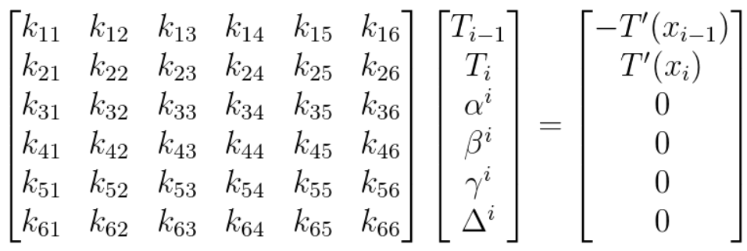

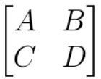

For a matrix M, Schur’s complement is equal to

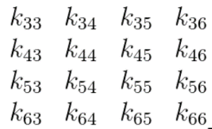This can then be extended to the inner nodal matrix by setting the following:

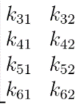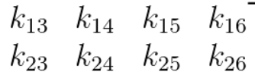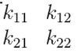

A = , B = C = D =

The complement is equal to a 2x2 matrix that is then assembled in the global matrix, with some example code below:

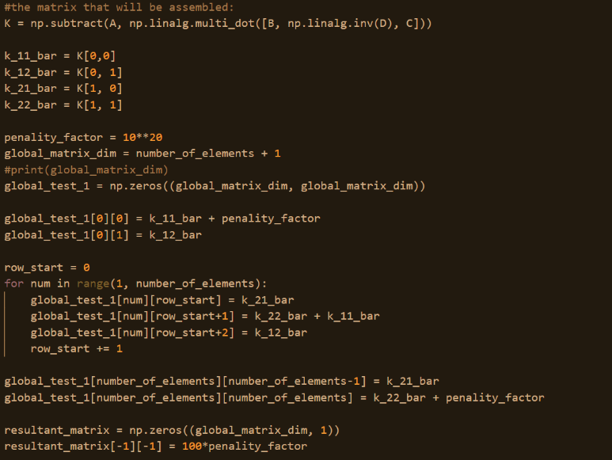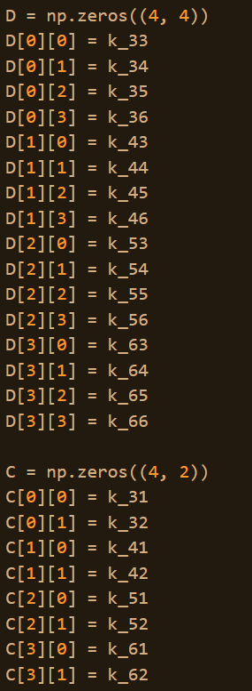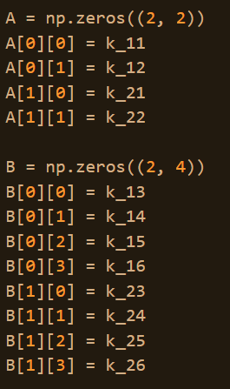

**5. Finding temperature distribution from global matrix with a penalty method**

The global matrix operation leaves us with the following equation for p =2, 4 elements:

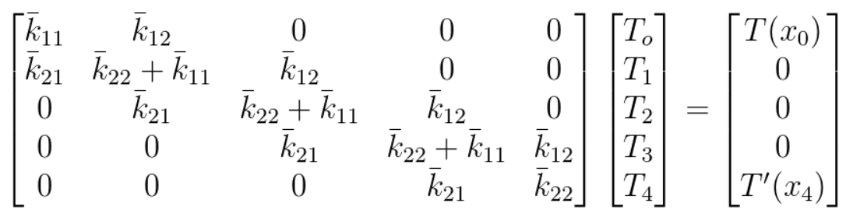

To diminish the effect of the rates of temperature at the end for case 1, a constant is applied to the boundary conditions, forcing the matrix to reduce the effect of unnecessary values in the boundary condition:

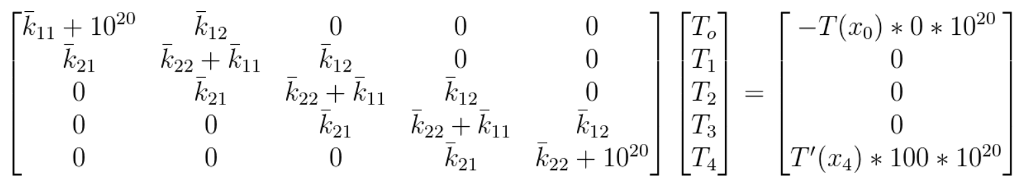

Relative to the large multiplication factors, the T’(x) values diminish, becoming:

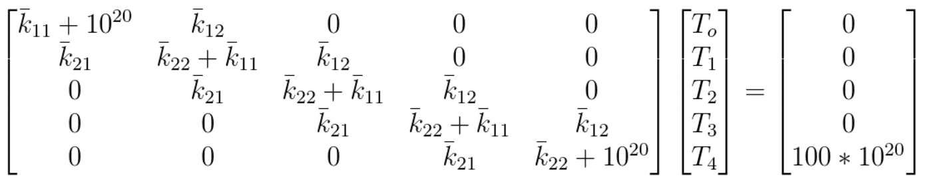

For case 2, the global matrix is changed from the initial boundary condition:

k = .5                         # thermal conductivity of material

    R = .1                         # radius

    h = alpha**2 * k * R / 2       # heat transfer coefficient

#setting the initial index to the condensed value + h/k

    global_test_1[0][0] = k_11_bar + h/k

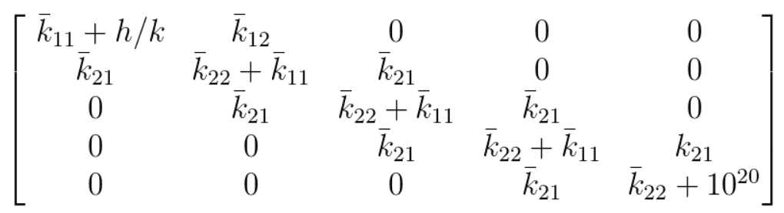

**6. Results and convergence:**

p = 1, case 1:

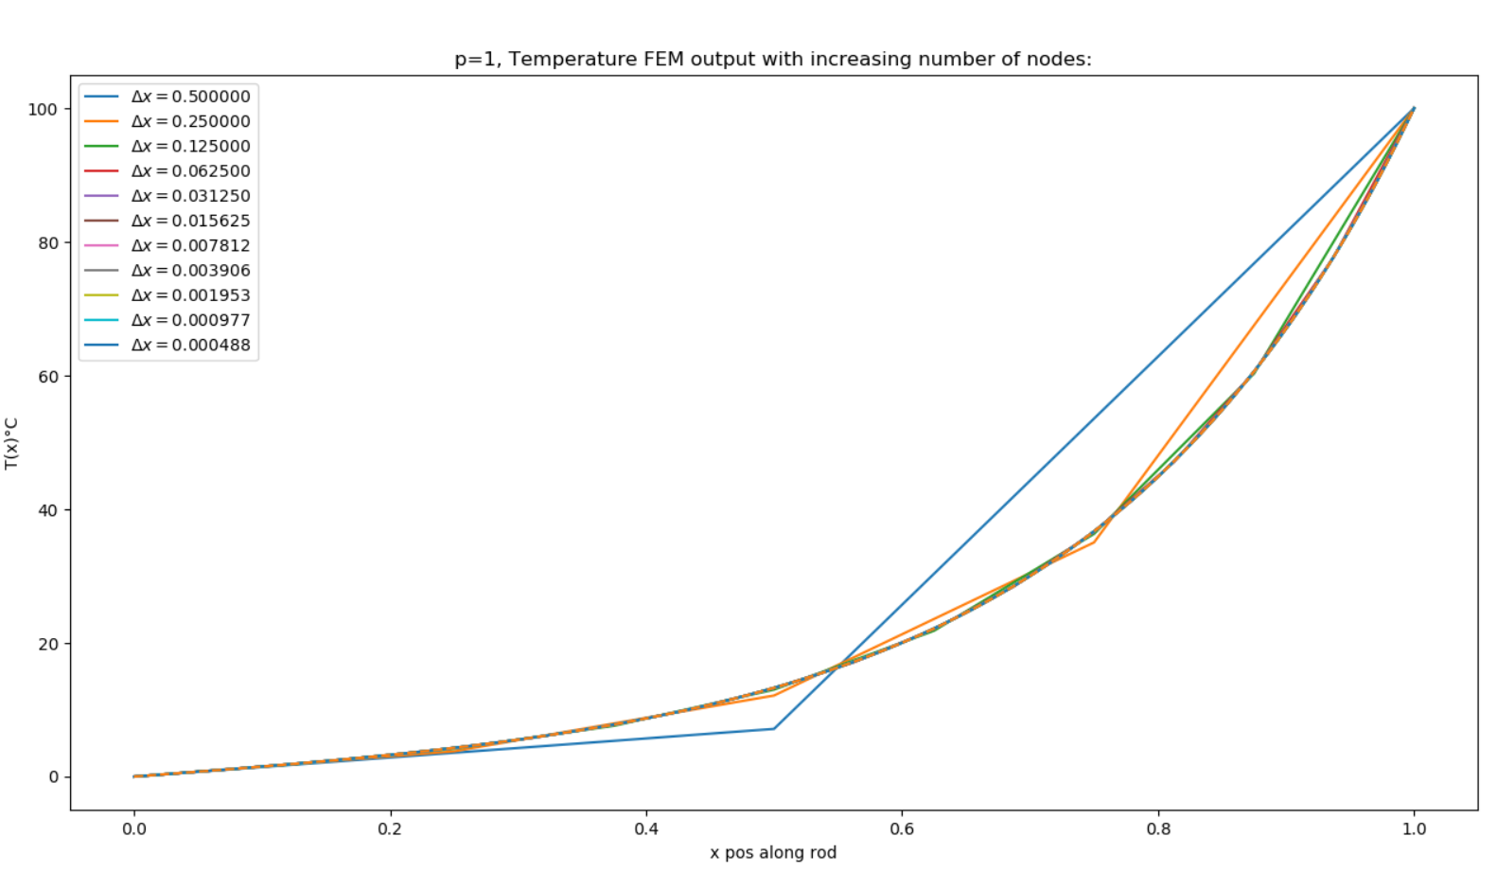

p = 1, case 1 convergence plot:

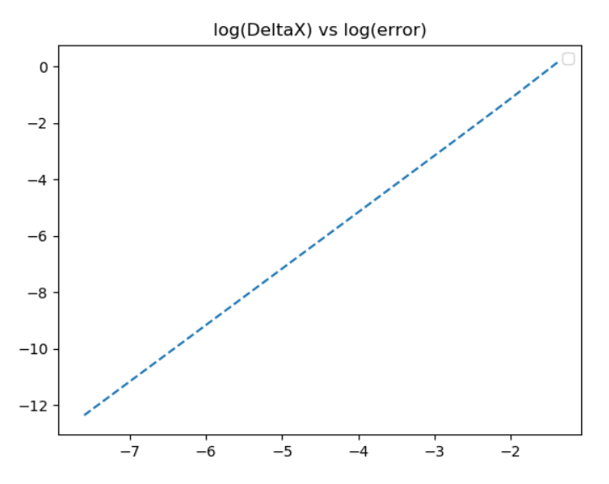

*after plotting values on google sheets, convergence found to be .5 with an value of 1.0

p = 1, case 2:

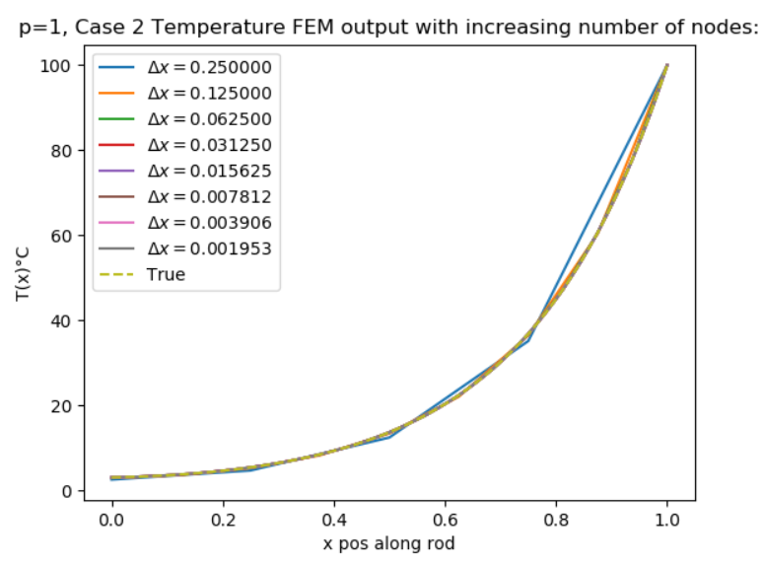

p = 1, case 2 convergence table and plot:

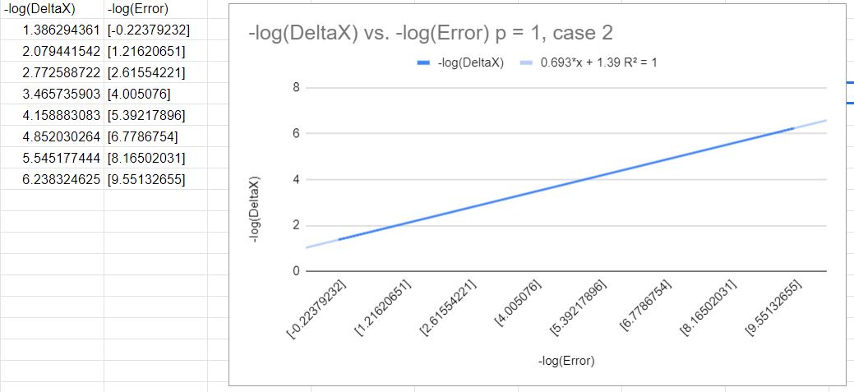

p=2, case 1:

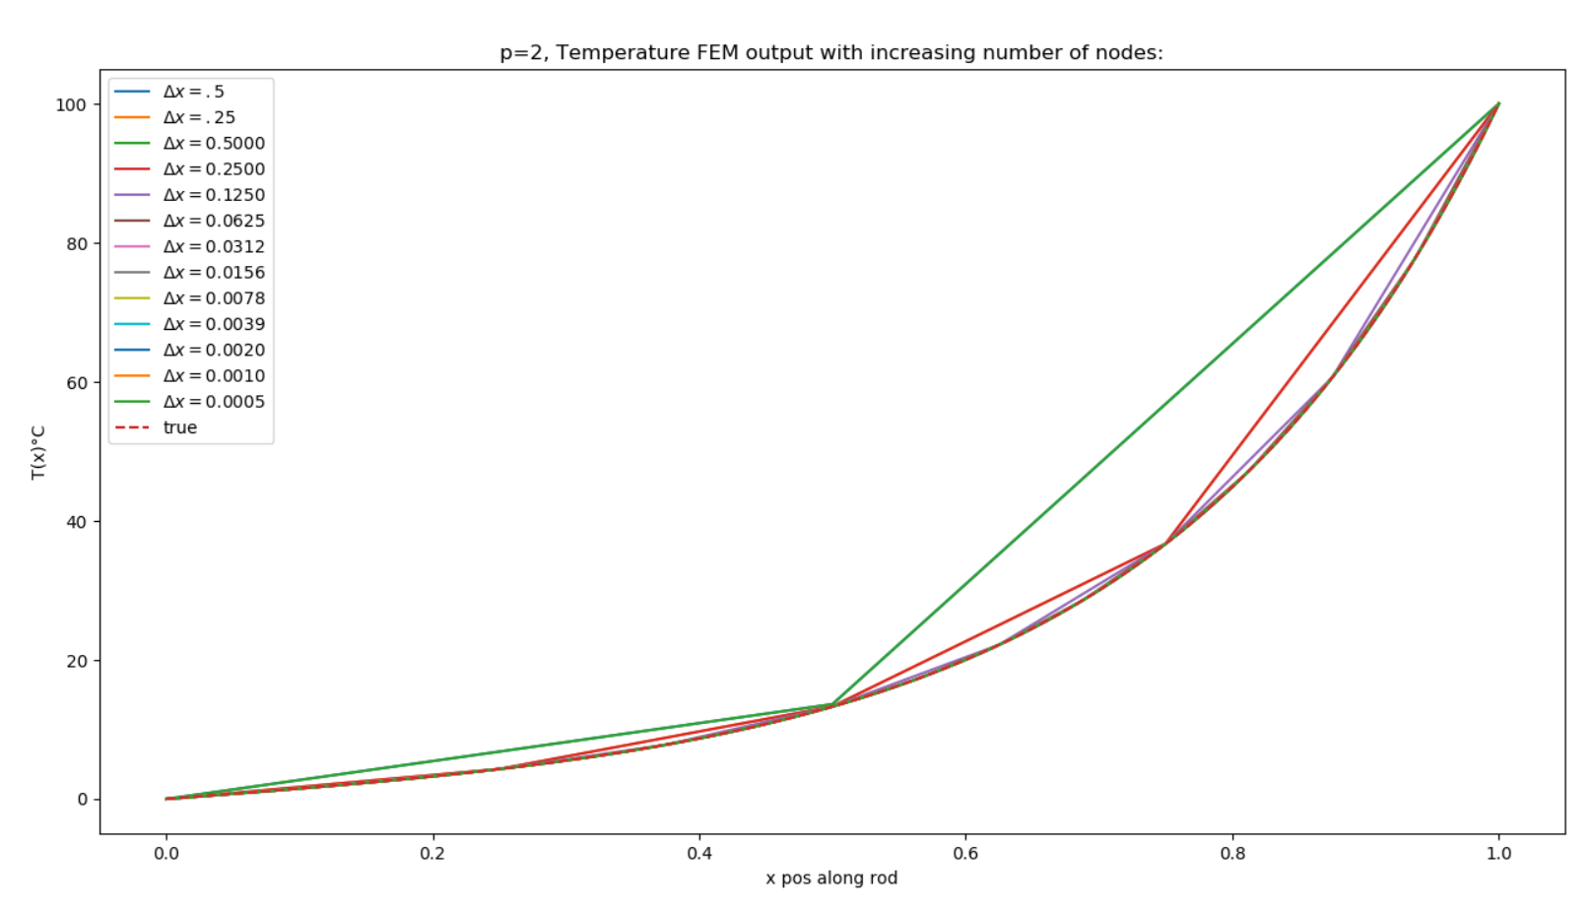

p = 2, case 1, convergence plot, converges with beta of approximately 3.41:

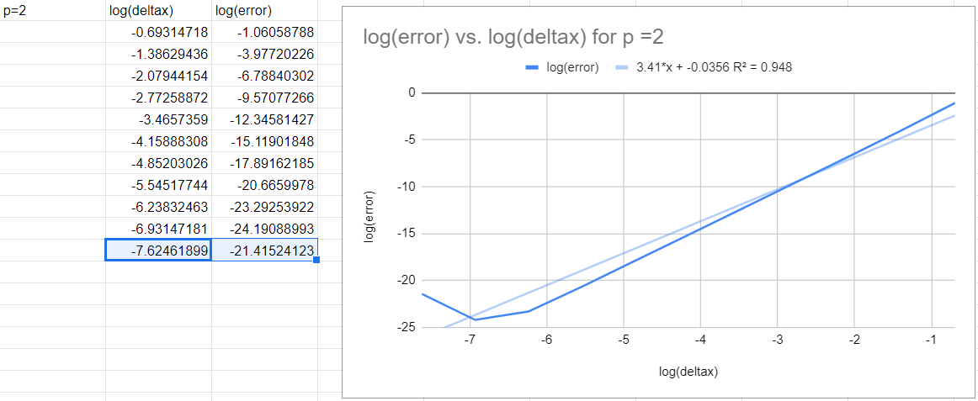

p = 2, case 2:

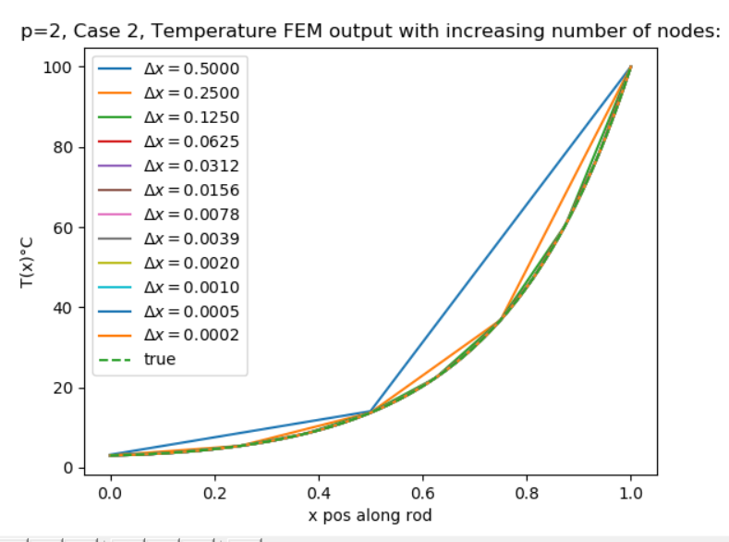

p = 2, case 2, convergence plot and data, beta approximately 4.01:

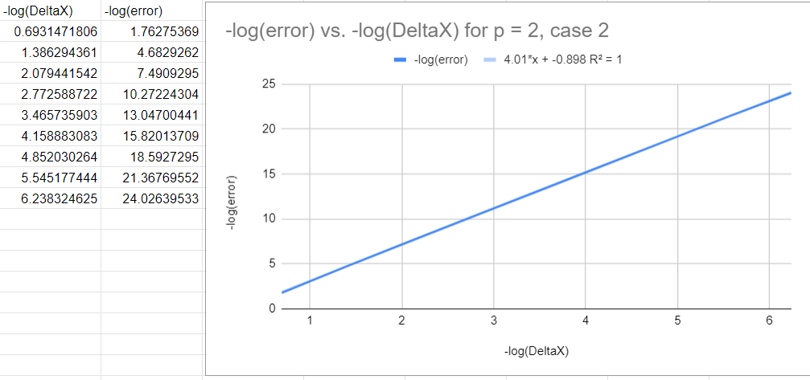

p = 3, case 1:

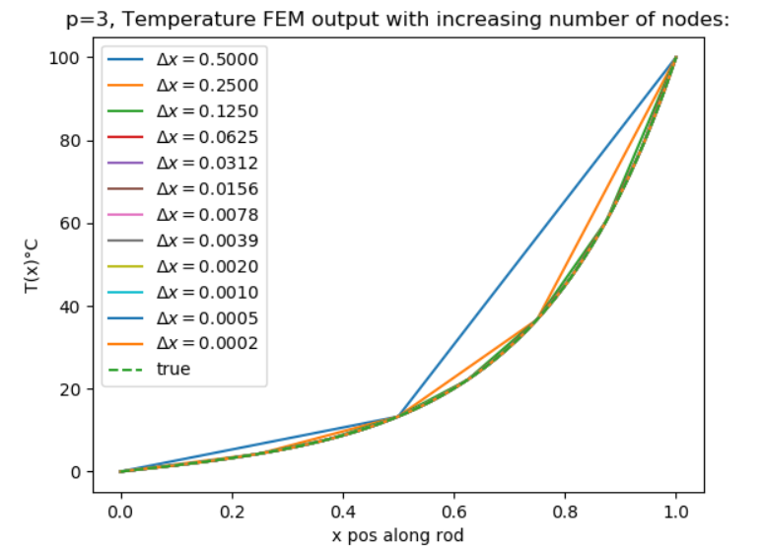

p = 3, case 1, convergence plot and data:

Beta approximately equal to 5.56

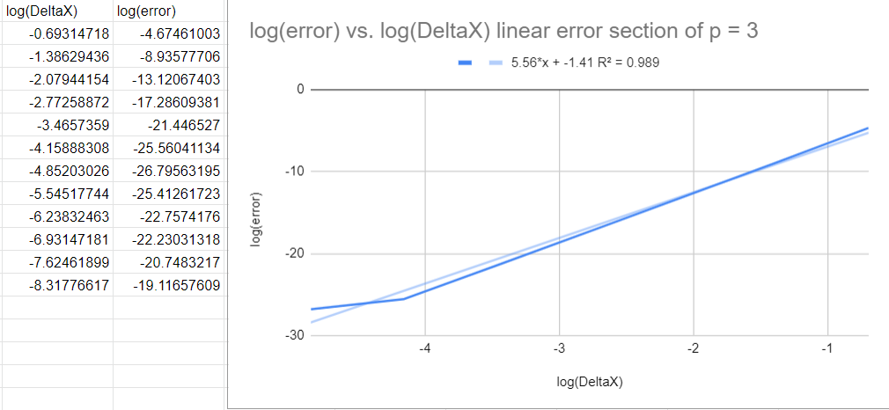

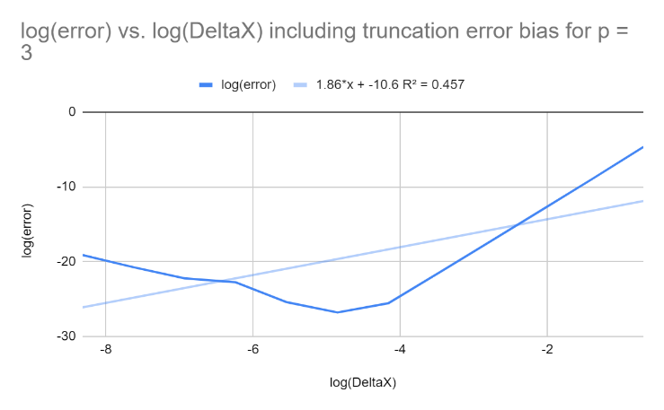

p = 3, case 2:

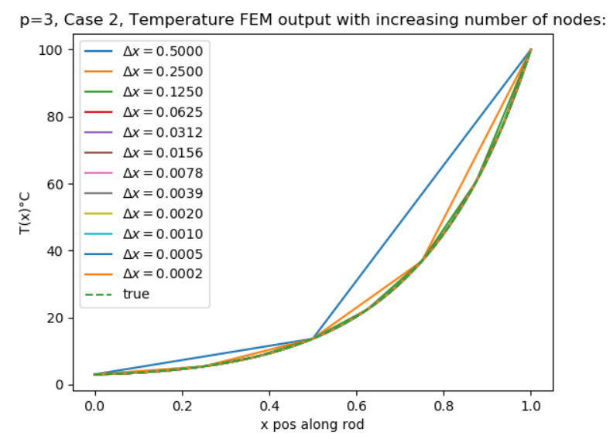

p = 3, case 2, convergence plot and data, beta is approximately 4.75:

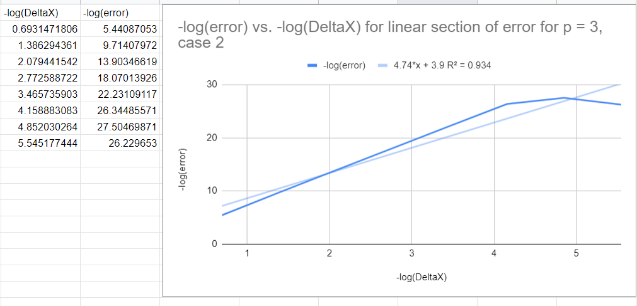

p = 4, case 1:

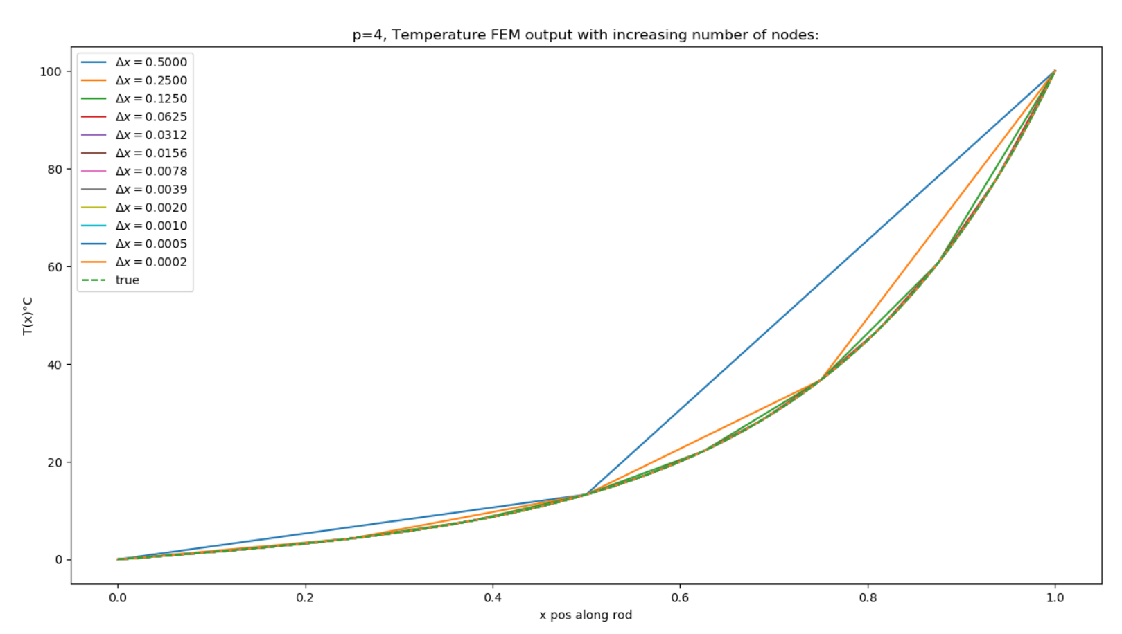

p = 4, case 1, convergence plot and data:

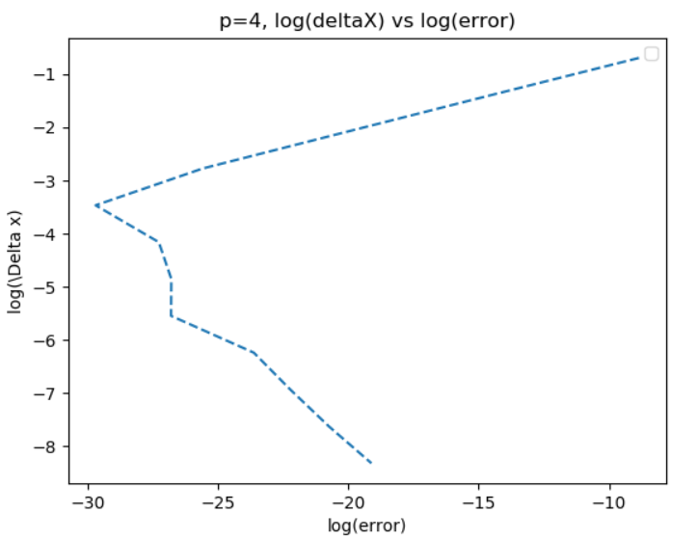

Beta approximately equal to 7.62

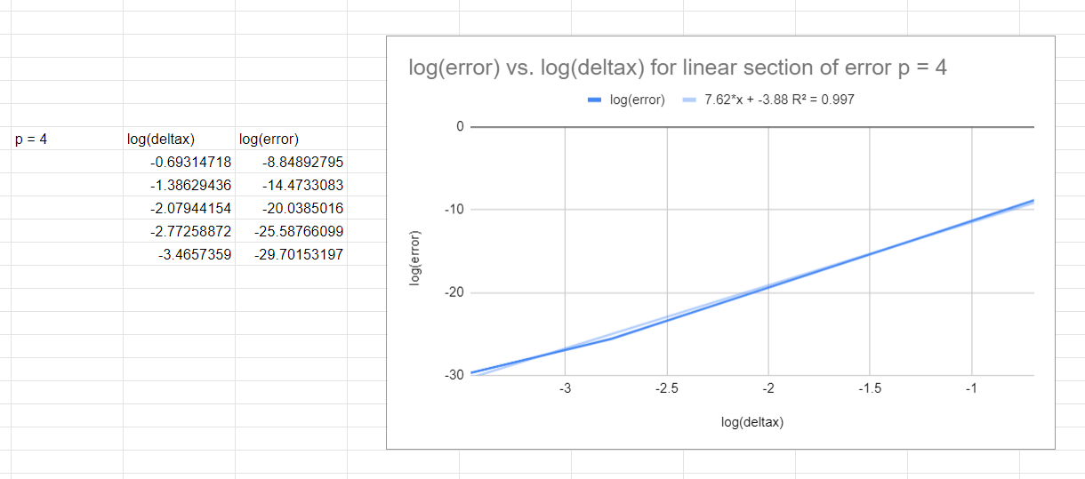

*truncation error starts to have large effects at earlier values of

p = 4, case 2:

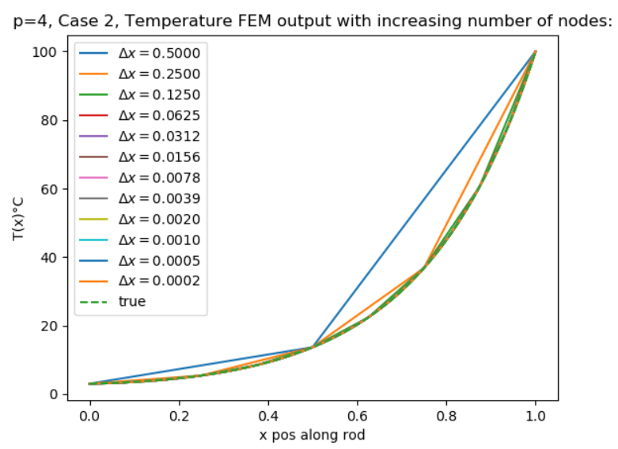

p = 4, case 2, convergence plot and data, beta approximately 5.88

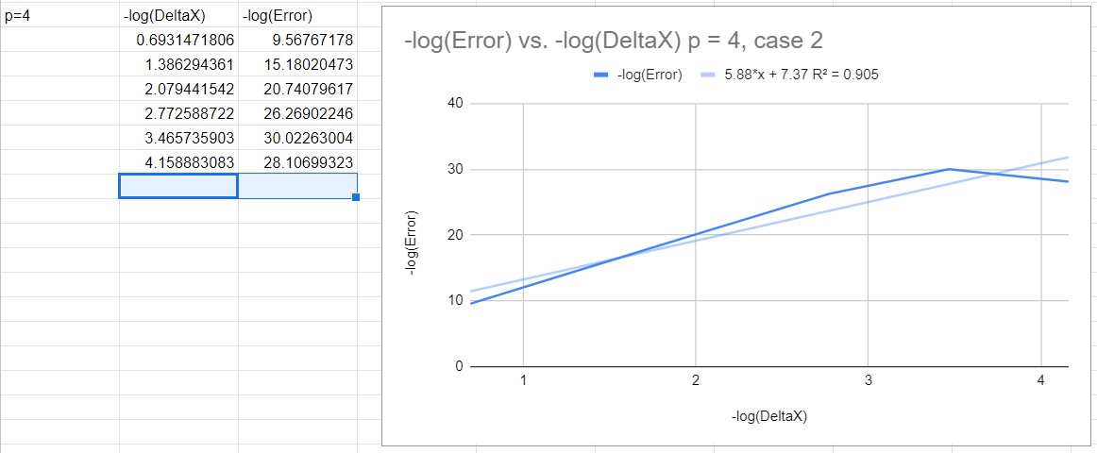

p = 5, case 1:

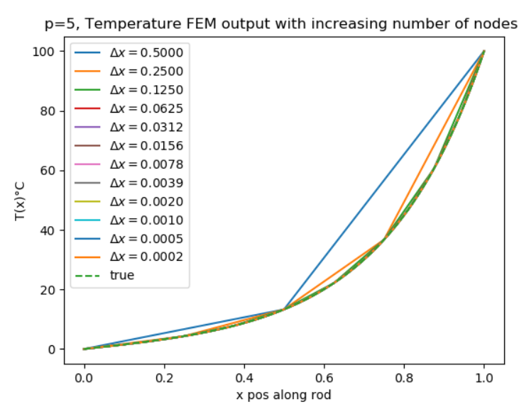

p = 5, case 1, convergence plot and data:

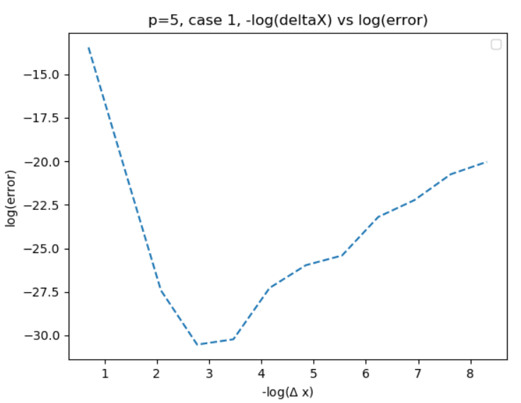

Linear section convergence rate approximately equal to 8.39:

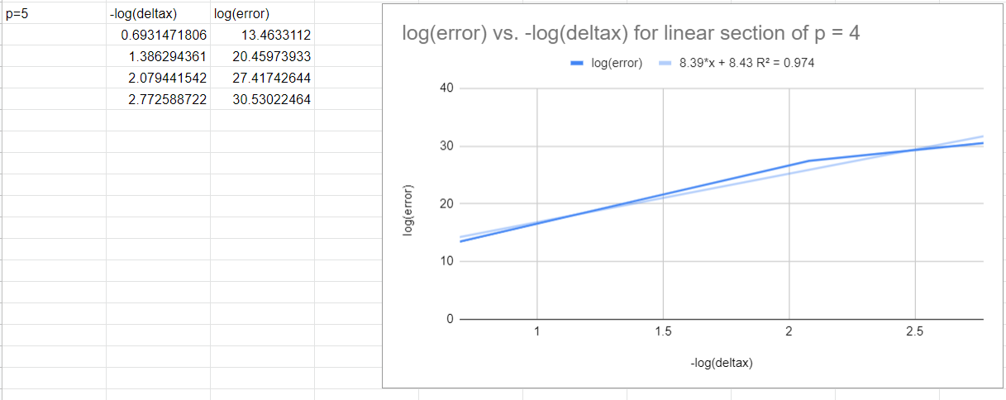

p = 5 case 2:

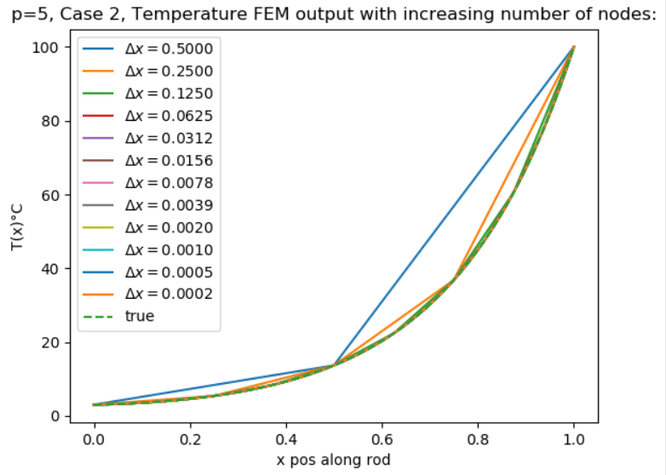

p = 5 case 2, convergence plot and data, beta is approximately 6.27

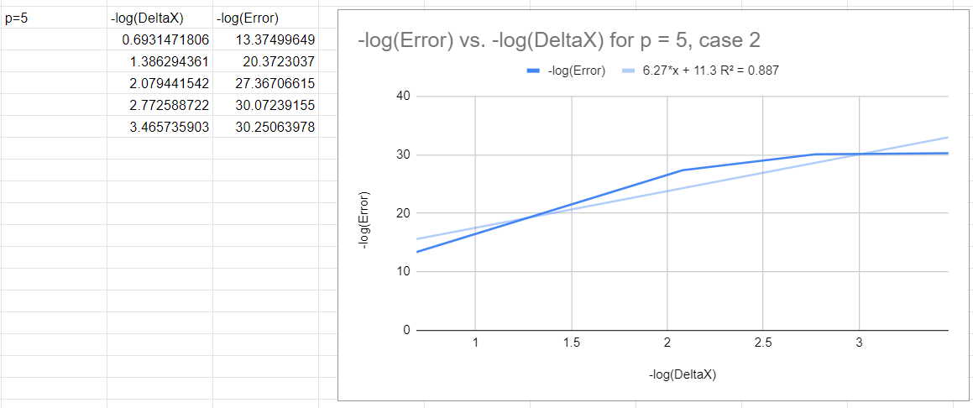

4. Heat flux, beta, extrapolated values:

1. By computing the heat entering the domain at x=L;

Heat loss entering the domain at x= L is found by using the definition of heat transfer across the bar:

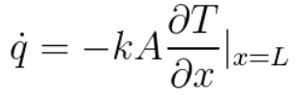

This can be approximated using Taylor series as follows:



Rearranging for T’(n) leads to

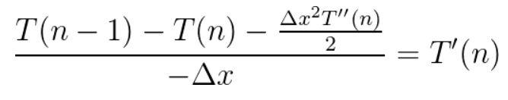

From our original second order differential equation, the following becomes true:

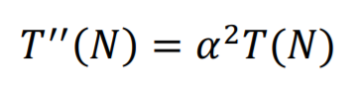

Solving for T’(n) and replacing this value in our heat loss equation leads to:

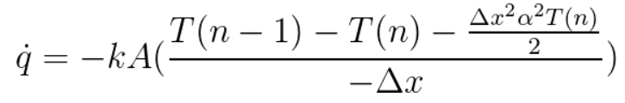

The rate of convergence between the exact solution can be defined by

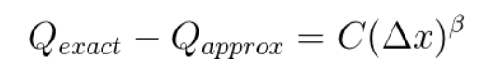

This can be rearranged with a successive approximation with:

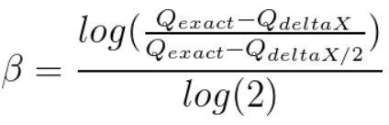

By computing the total heat flux exiting the domain through Newton Cooling from the lateral surface and the cross-section at x=0. Total heat flux can be calculated by

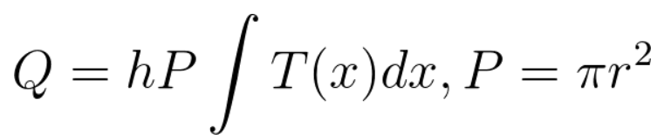

Using Simpsons rule, the total lateral heat flux can found and programmed in python. The lateral heat can also be extrapolated using Richardson extrapolation with the following relationship:

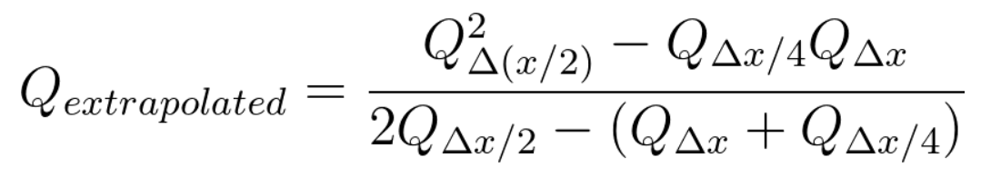

Convergence for p = 5, case 1, with heat flux, extrapolated values, and Beta values are given from the code below:

 Q_approx_list = []

    flux_array = []

    total_beta_list = []

    total_error_list = []

    total_error_list.append(error)

    k=.5

    R = .1

    h = alpha**2*k*R/2

    A_cross_section = np.pi * R**2   # cross sectional area

    T_n = temp_outputs[len(temp_outputs)-1]

    T_n_min1 = temp_outputs[len(temp_outputs)-2]

    q_dot_env_approx = (-k*A_cross_section*(-T_n_min1/delta_x+T_n/delta_x + alpha**2*T_n*delta_x**2/(2*delta_x)))

    # not about this value, it is a value taken from Bradshaw report. This value is -6.283185307179588 from q_total variable in Hmwk1 python code, however the FDM values also seem to converge to -6.280376

    q_dot_env_exact = -6.280376

    Q_approx_list.append(temp_outputs[0])

    beta = np.absolute(np.log((analytical_sol_case1(6)[0] - Q_approx_list[len(Q_approx_list)-1])  / (analytical_sol_case1(6)[0] - Q_approx_list[len(Q_approx_list)-2])) / np.log(2))

    T_approx = temp_outputs[0]

    T_exact = analytical_sol_case1(6)[0]

**Conclusion**:

Using finite element models, the Temperature as a function of position on the heat rod can be estimated. The current models used in this assignment make use of hierarchical functions, condensation, assembly, and penalty functions to find the temperature along the rod. The results were found using p = 1, 2, 3, 4, and 5 for two different boundary conditions. The values of convergence reach their expected values for all orders for case 1 of about 2*p. As the deltaX increased, for larger p values, the convergence began to be dominated by truncation error as expected. This can likely be reduced by using other numpy extended precision functions in python. This code could also be improved by making a function that will automatically calculate Schur’s complement based on the p value instead of hardcoding each condensation for each value of p.

Compared to the error graphs of FDM, for the same deltaX, FEM reaches better precision, noted from the log(deltaX) and log(error graphs).

This assignment was useful in seeing how quickly the accuracy can improve with higher orders of FEM convergence. ­­